**Problem 1**

1-P

A-P

1

2

2-P

3

4

**A**

**P**

3

4

1

2

3-P

4 x 20 = 80 mm

**Problem 2**

**40 mm**

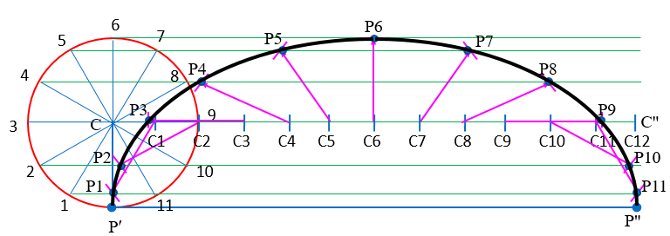

πD ≈ 125.7 mm

**Problem 3**

VF = 60 mm

e = 0.65

⸫ VF / CV = 0.65

=> CV = 60 / 0.65 = 92.3 mm

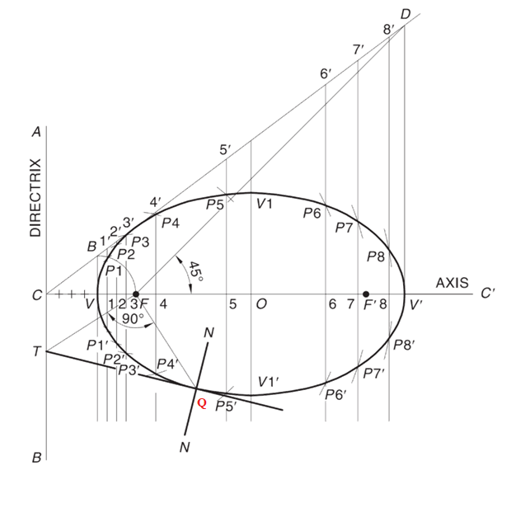

176 mm

60 mm

92.3 mm

**USE SUITABLE SCALE**

**Problem 4**

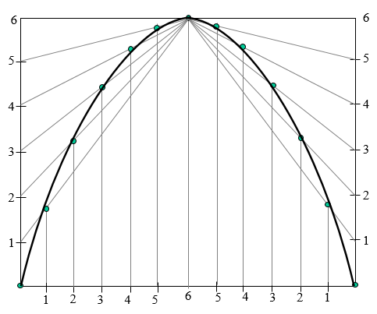

40 mm

70 mm